Lab Report 6

Databases - CSC 3320 121

Hudson Arney

27 March 2024

What have you learned from the lab?

* Setting up and configuring different storage engines in MySQL
* The impact of different storage engines on SQL query performance

What caused issues?

* It was difficult to keep track of all the steps and documentation.
* I had to restart the lab more than once
* I feel like I did too much.

# Execution Times:

|  |  |  |  |
| --- | --- | --- | --- |
|  | InnoDB | MyISAM | MEMORY |
| Q1 - join | 0.01215425 | 0.0004735 | 0.648445 |
| Q2 - restrict | 0.000267 | 0.00040325 | 0.000403 |
| Q3 - range query | 0.010975 | 0.0034245 | 0.25417925 |
| Q4 - insert | 0.017352 | 0.0131295 | 0.01350575 |
| Q5 - update | 0.03215225 | 0.02911075 | 0.02338625 |

Setup:

Observations:

**INNODB**

**Q1**

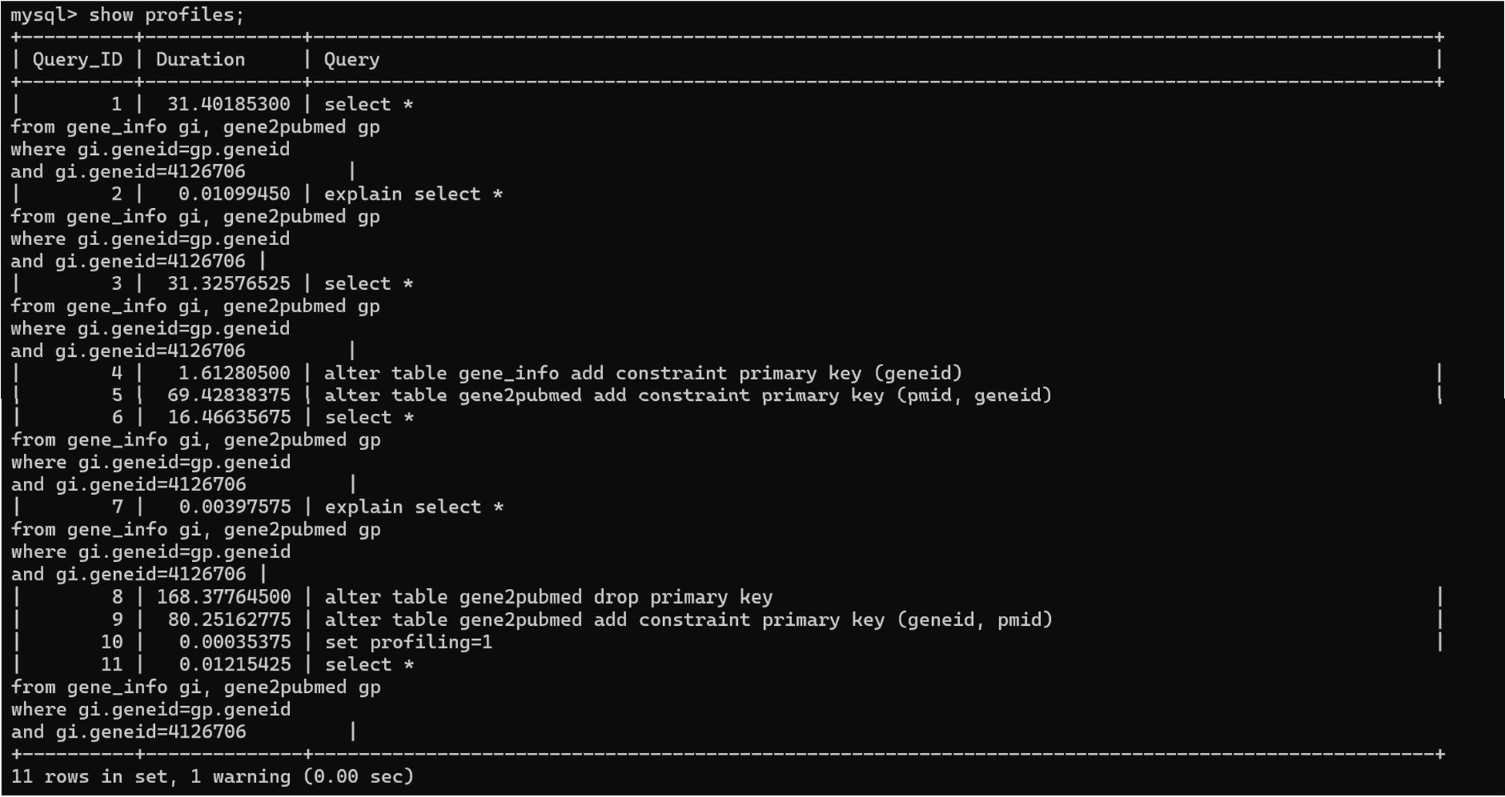

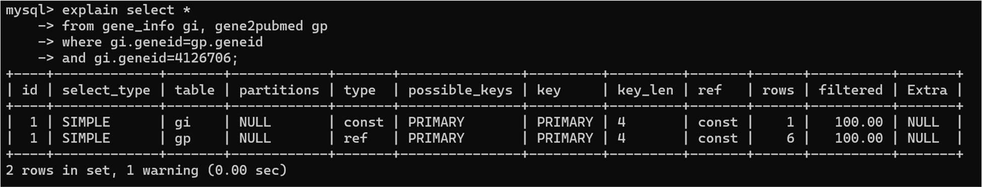

**Q2**

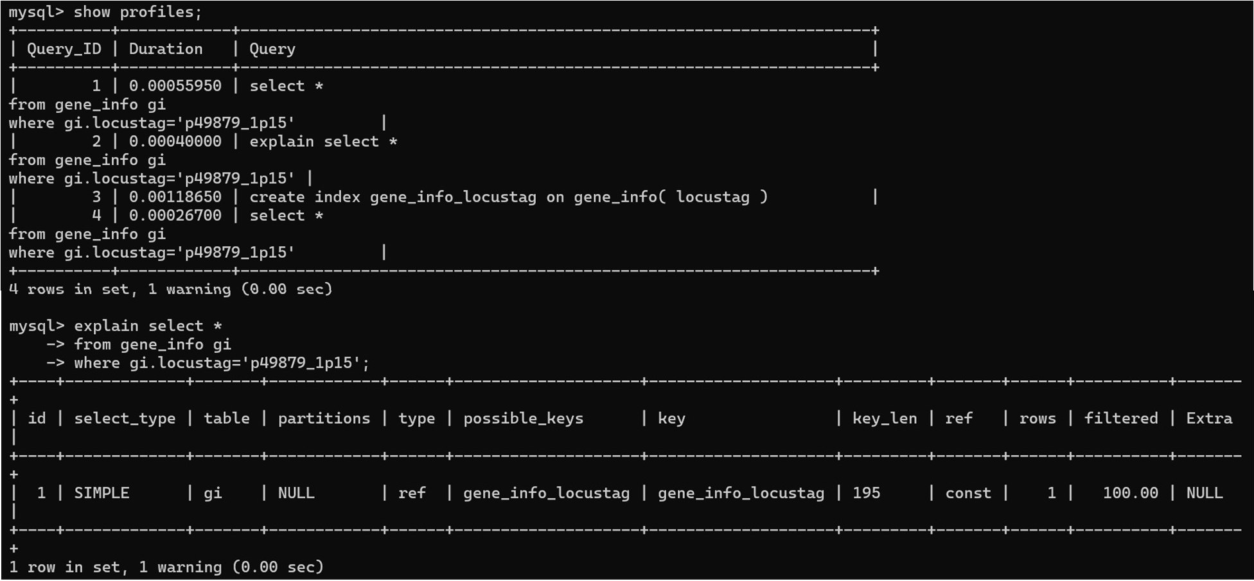

**Q3**

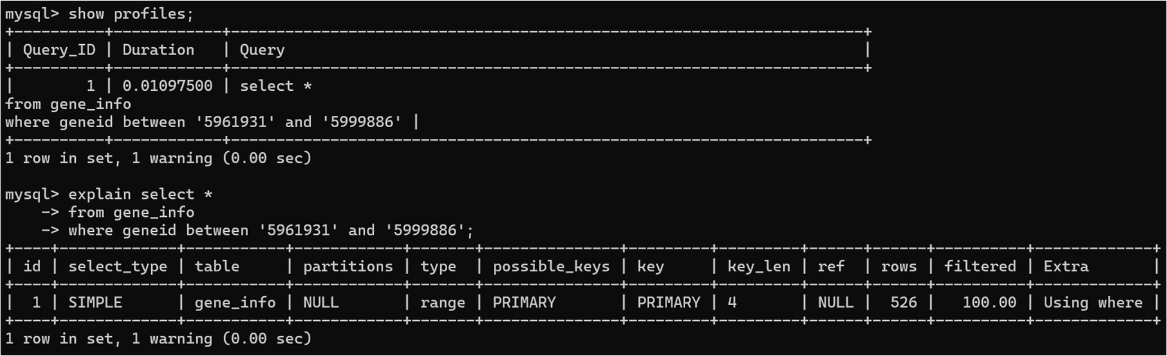

**Q4**

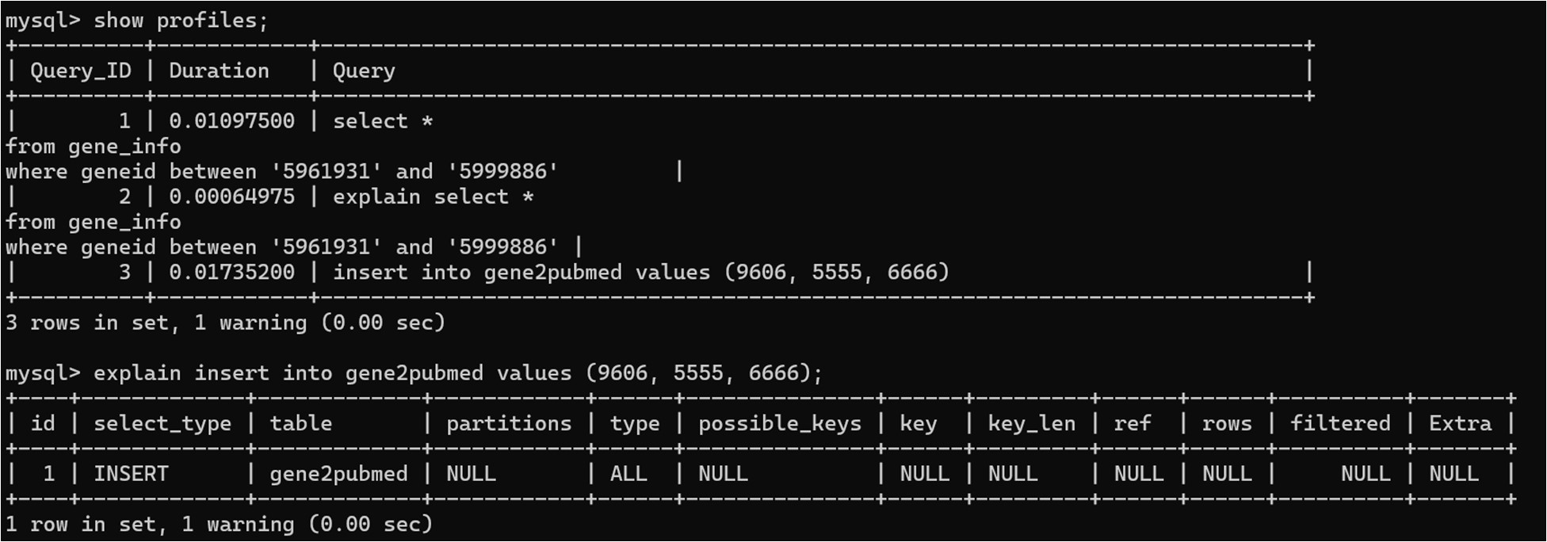

**Q5**

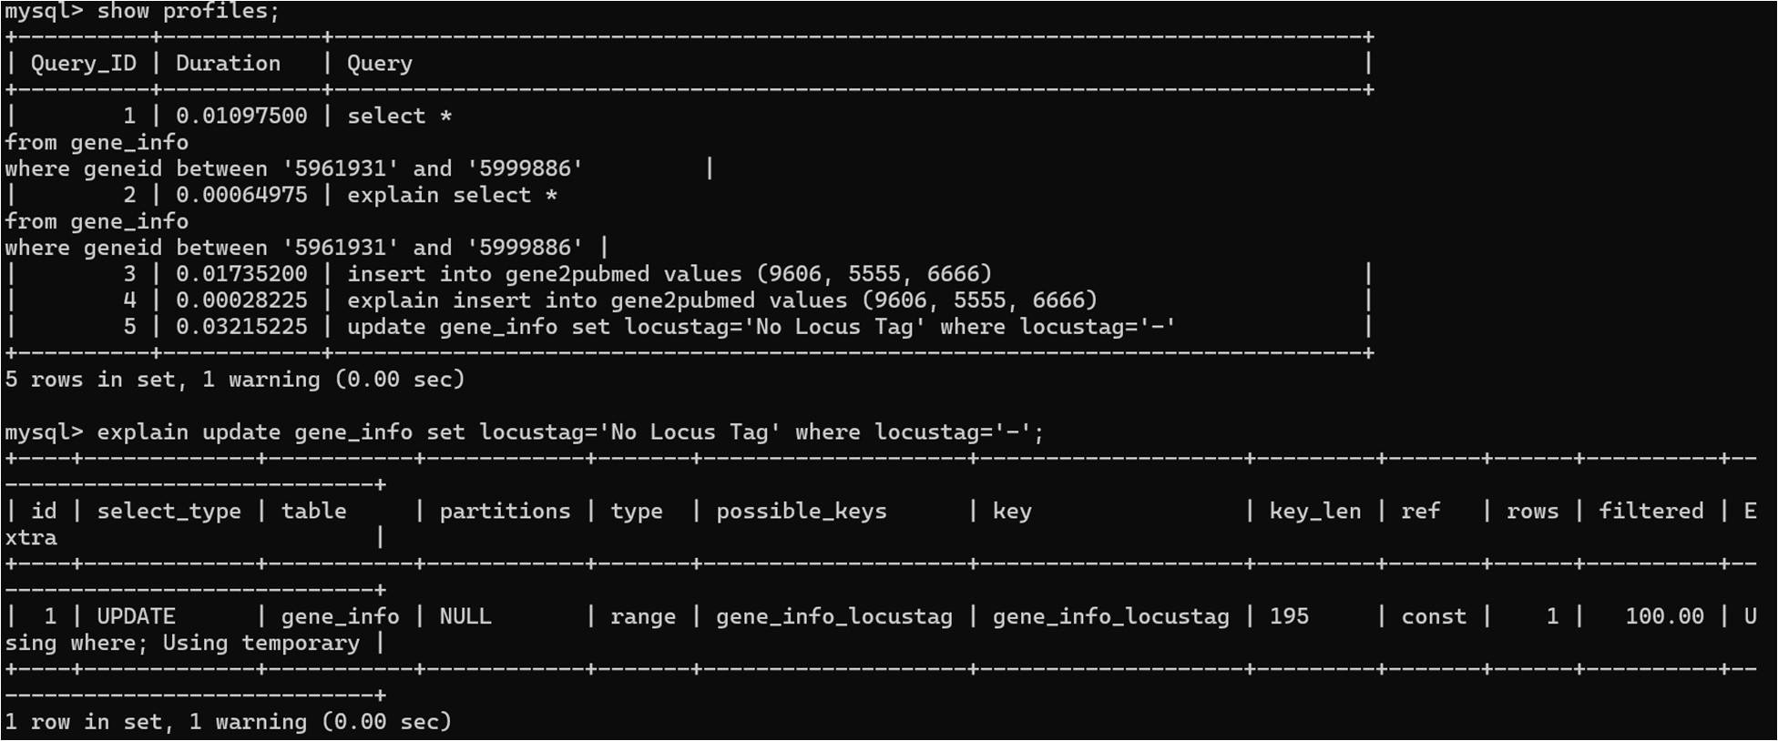

**MyISAM**

**Q1**

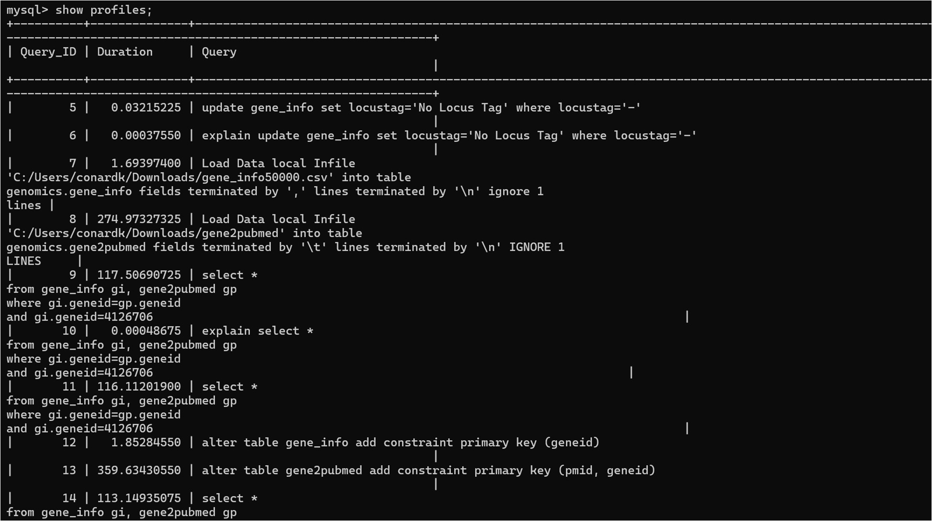

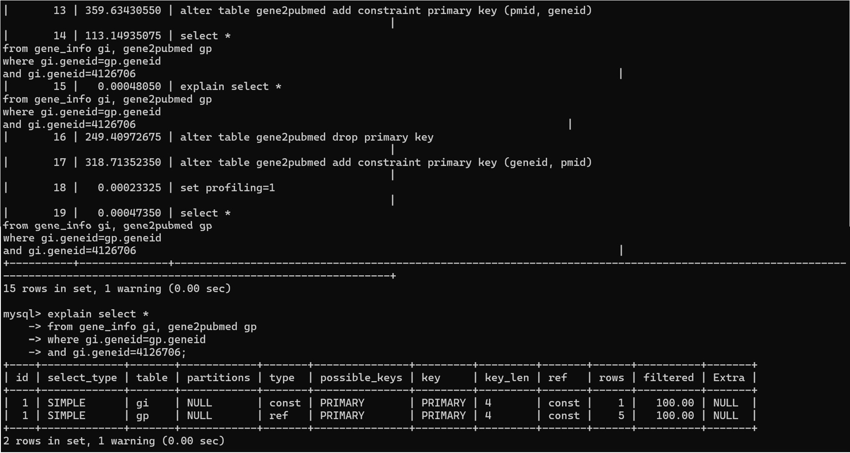

**Q2**

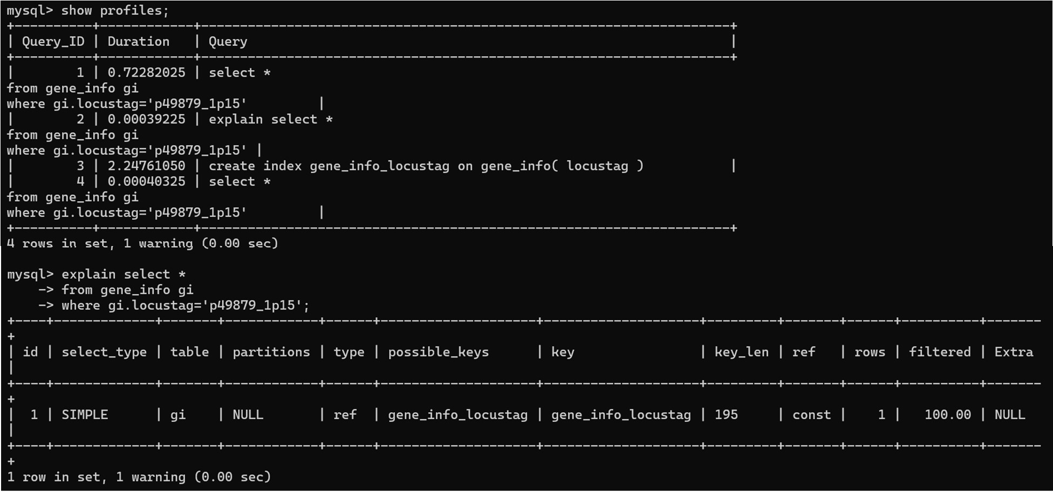

**Q3**

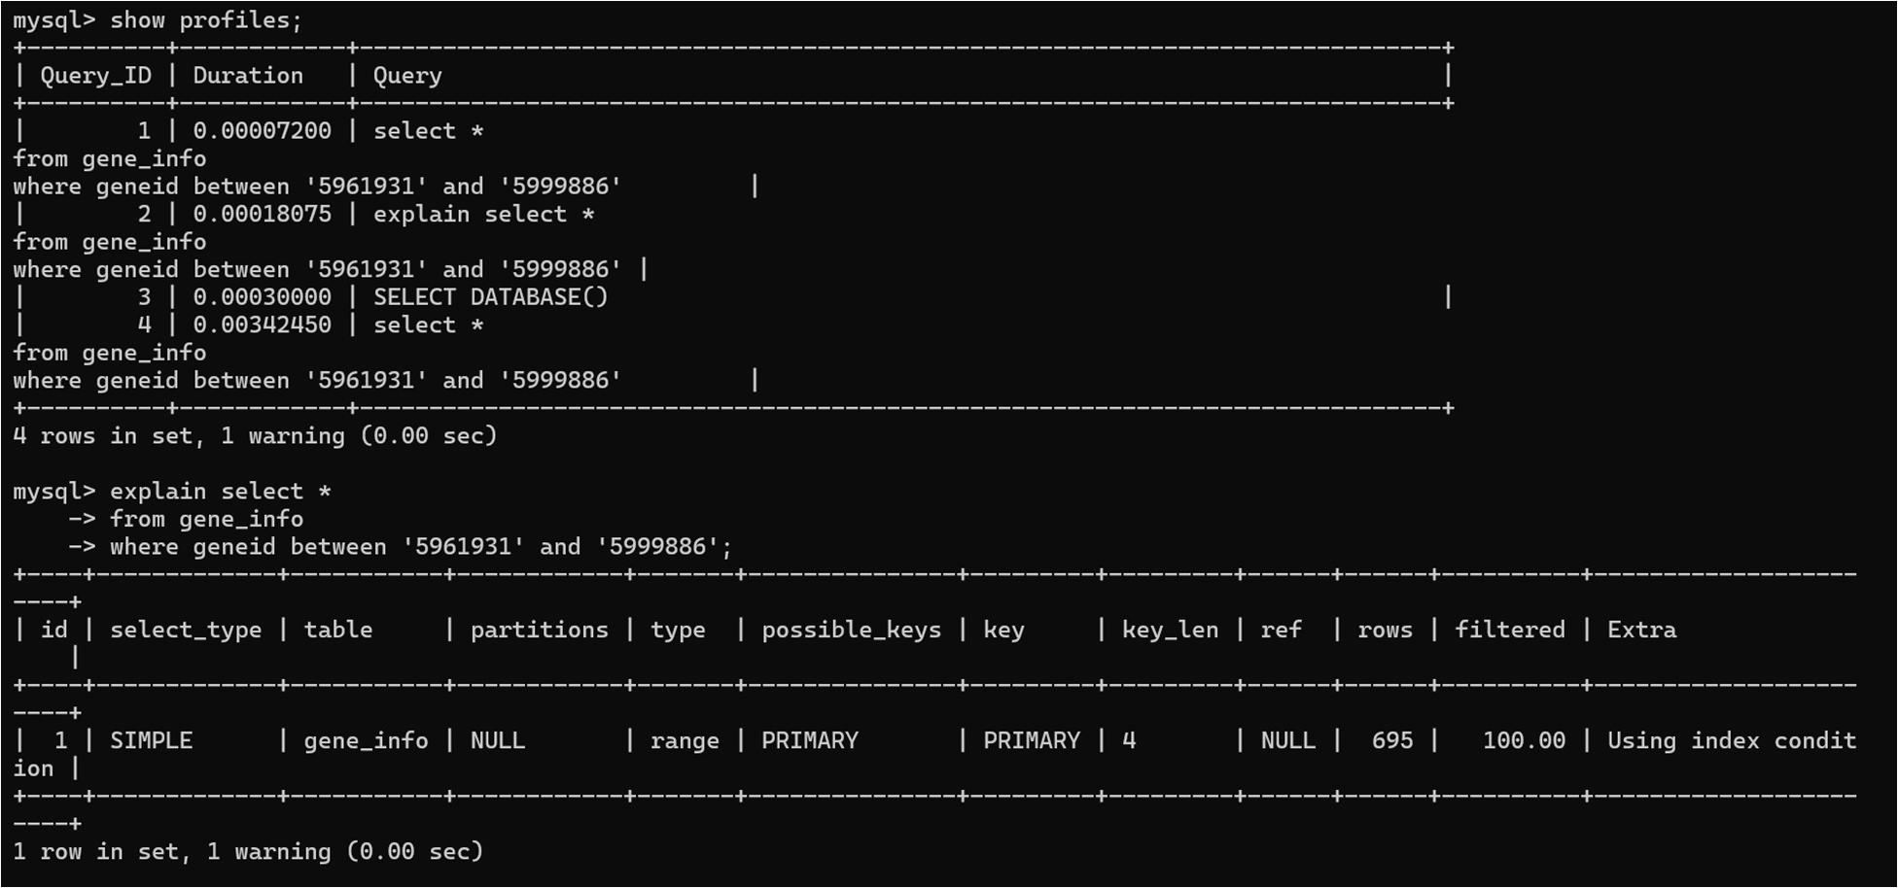

**Q4**

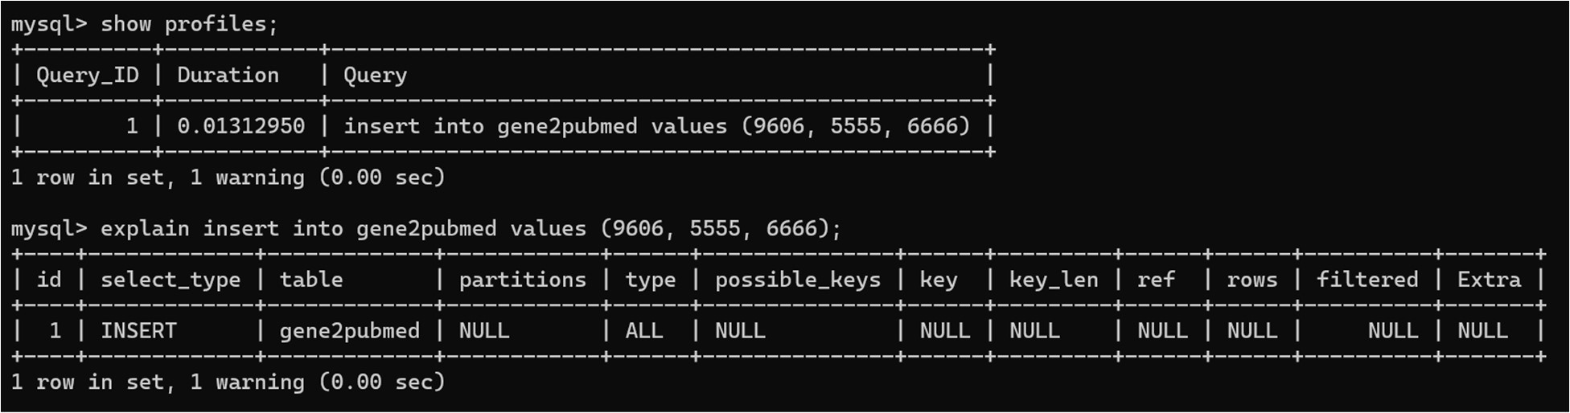

**Q5**

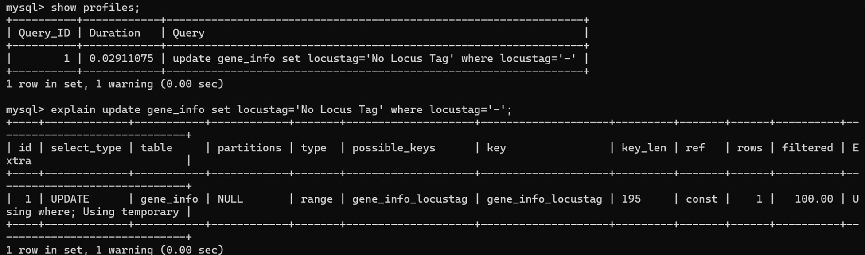

**MEMORY**

**Q1**

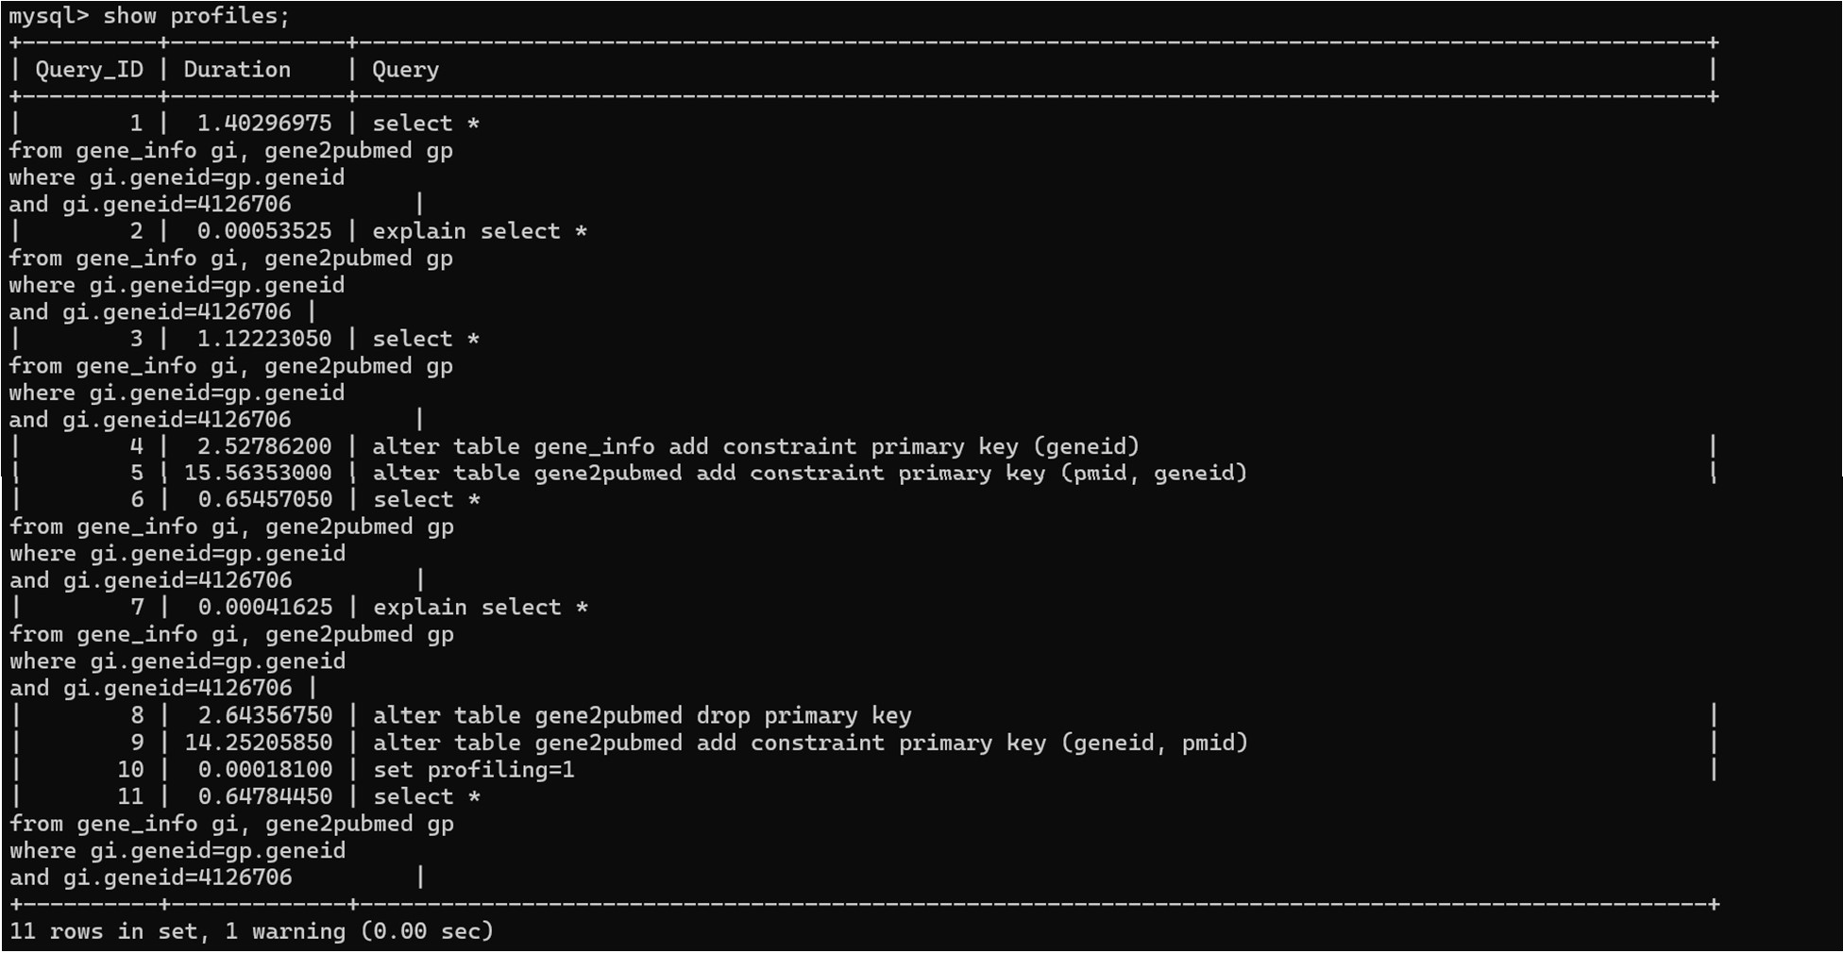

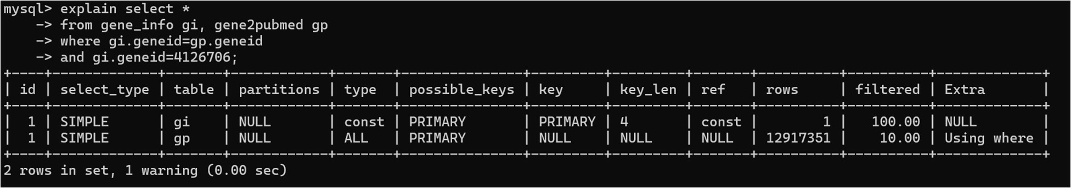

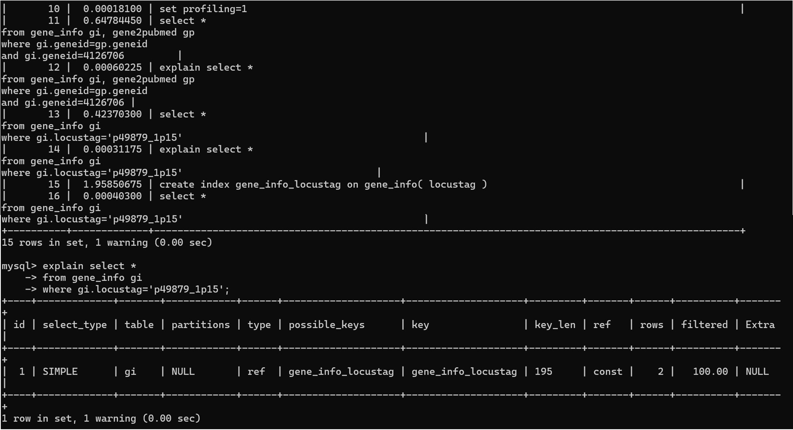**Q2**

**Q3**

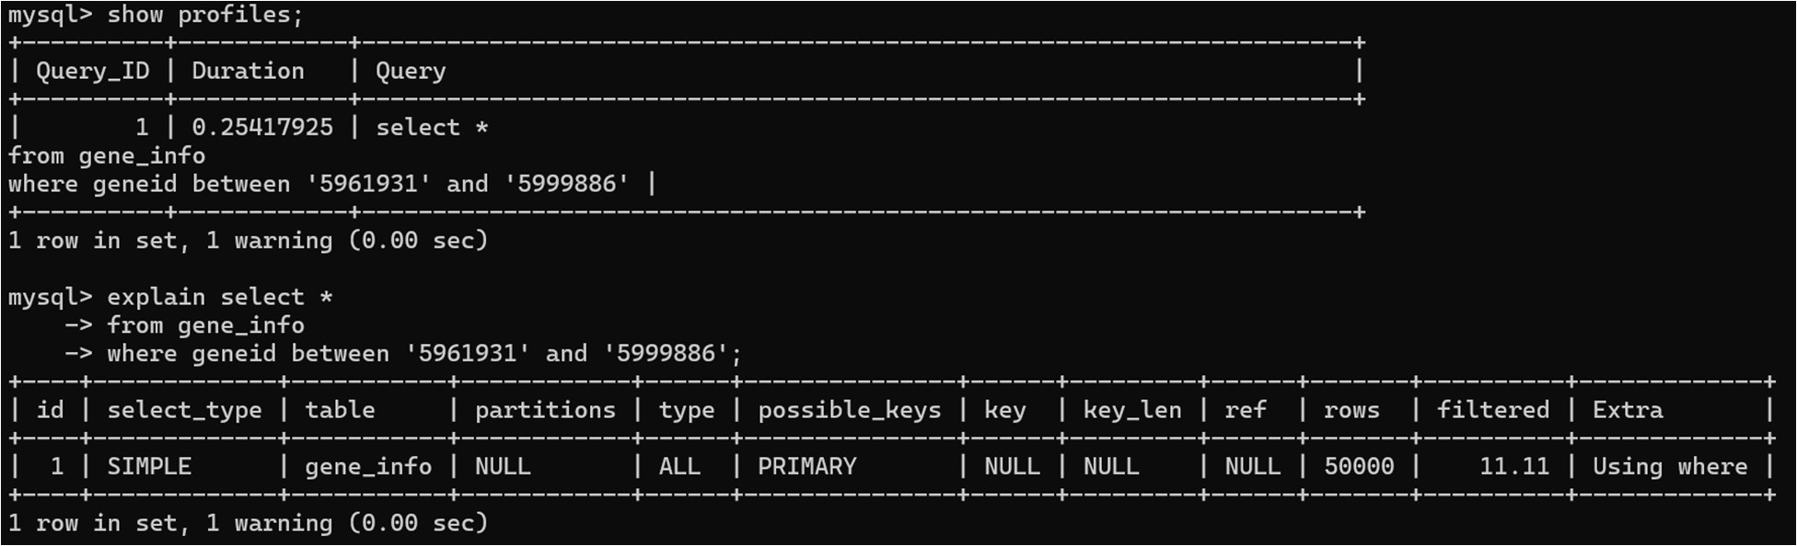

**Q4**

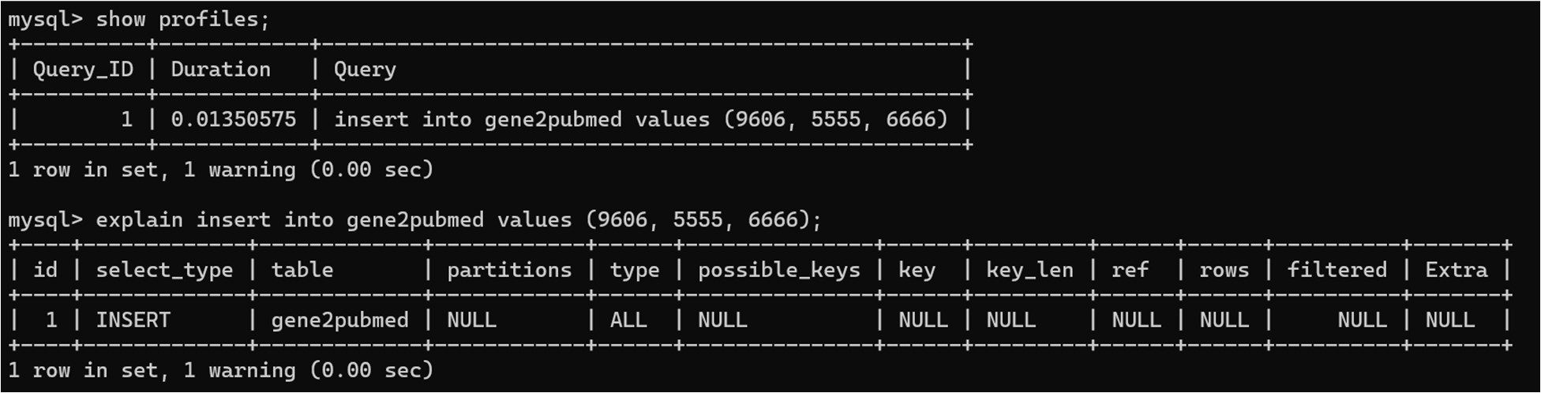

**Q5**

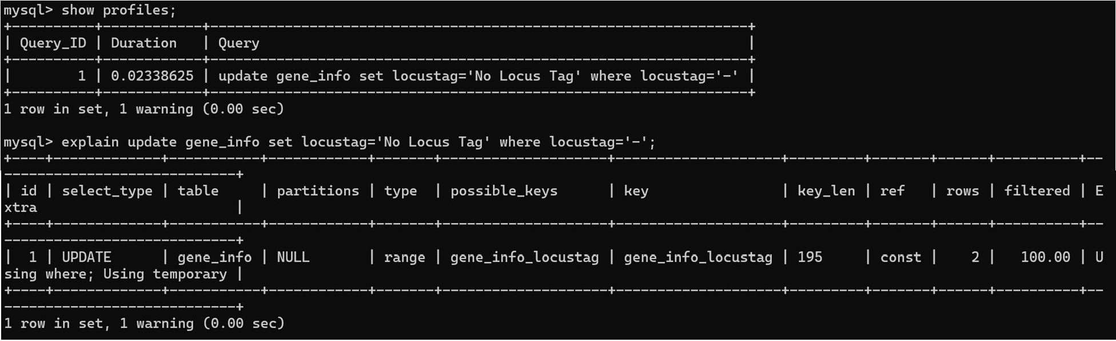

Notes:

File Path for Gene Info:

C:/Users/arneyh/OneDrive - Milwaukee School of Engineering/Current Classes/CSC 3320 - Databases/Labs/Lab 6/files/gene_info50000.csv

File path for Gene2PubMed:

‘C:/Users/arneyh/OneDrive - Milwaukee School of Engineering/Current Classes/CSC 3320 - Databases/Labs/Lab 6/files/gene2pubmed’

Reset profiles:

SET @@profiling = 0;

SET @@profiling_history_size = 0;

SET @@profiling_history_size = 10;

SET @@profiling = 1;

SET GLOBAL local_infile=1;